WINDCON
— Leader of Motor Control —

Permanent Magnet Synchronous Motor Controller
USER MANUAL
Model: FDK3533C-XC (Electric Tricycle Version)
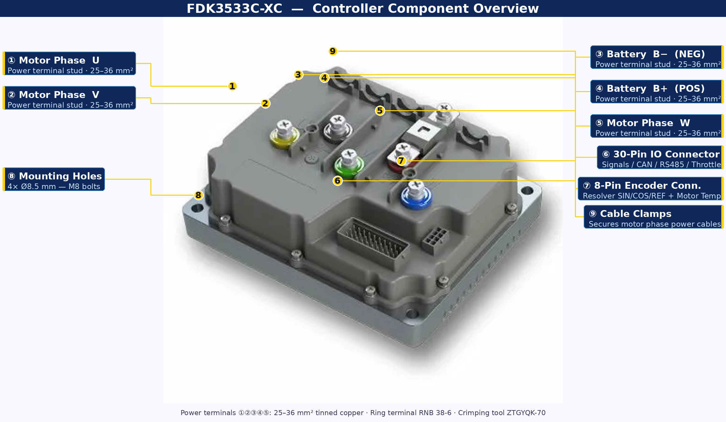
Figure 1 — FDK3533C-XC annotated controller — all major components labelled

Document Information
Version: V1.0 EN | Based on Oct 2023 original | For internal / NDA use only
Guilin Windcon Technology Co., Ltd. | www.windcon.com.cn

Table of Contents
Preface & Version History | 3
1 Safety Information | 3
2 Product Overview | 5
3 Controller Port Description | 6
3.1 Physical Layout | 6
3.2 30-Pin IO Connector | 7
3.3 8-Pin Encoder Connector | 9
3.4 Power & Motor Terminal Studs | 10
4 Controller Resource Configuration | 10
4.1 Signal Inputs | 10
4.2 Signal Output | 11
4.3 Voltage Outputs | 11
4.4 Communication Interfaces | 11
4.5 Encoder & Temperature Feedback | 12
4.6 Original Wiring Diagrams | 12
5 Installation | 14
5.1 Environmental Requirements | 14
5.2 Mechanical Dimensions | 14
5.3 Electrical Installation Safety | 15
5.4 Post-Installation Checklist | 15
6 Commissioning | 16
7 Typical Problems & Fault Analysis | 17
8 Fault Alarms & Remedies | 17
Appendix A — List of Figures | 19
Appendix B — List of Abbreviations | 20
Appendix C — Technical Explainer Diagrams | 22
C.1 Resolver Operating Principle | 22
C.2 FOC / SVPWM Control Loop | 22
C.3 Signal Logic Guide | 23
C.4 Fault Beep Code Chart | 23
C.5 Integration Guide | 24
C.6 Commissioning Flowchart | 25

Preface
Thank you for your support of Windcon FDK series motor controllers. This manual covers FDK3533C-XC safety, mechanical and electrical installation, port descriptions, commissioning, maintenance, and integration guidance with fully annotated diagrams.
Read carefully before use and retain for future reference. Contact Windcon technical support for assistance.

Version History
Date | Version | Description
October 2023 | V1.0 | Initial Chinese release
(current) | V1.0 EN | English translation + all annotated diagrams + appendices + explainer sections

1 Safety Information

1.1 Safety Alert Levels

⚠ DANGER — Death or serious injury WILL result if instructions are not followed.

⚠ WARNING — Death or serious injury MAY result if instructions are not followed.

⚠ CAUTION — Minor injury or equipment damage may result if instructions are not followed.

1.2 General Safety Declarations
- Read and follow all safety information before installing, operating, or maintaining this product.
- Safety warnings in this manual are supplementary and do not represent all possible hazards.
- Use only in environments meeting design specifications. Non-compliance voids warranty.

Windcon assumes no liability for damage caused by:
- Non-compliance with operating instructions
- Unauthorized modification or use in special applications (e.g. lifting equipment)
- Improper operation
- Natural events such as flooding or lightning
- Damage incurred during transportation

1.3 Safety Precautions by Phase

Wiring
⚠ DANGER — Wiring
- Non-professionals STRICTLY PROHIBITED from wiring!
- Never wire while power is connected — risk of electric shock.
- Cut ALL power and wait at least 15 minutes before touching — capacitor residual voltage remains.
- Ensure reliable grounding of all equipment — risk of electric shock if omitted.
- Follow ESD procedures; wear anti-static wristband when wiring.

⚠ WARNING — Wiring
- NEVER connect power supply to motor output terminals U/V/W — causes damage and may cause fire!
- Ensure controller and motor terminal phase sequence match exactly to avoid stall or runaway.
- Cables must meet required cross-section and shielding. Shielded cable shield: single-end ground only.
- After wiring: verify polarity carefully — reversed polarity damages product or motor encoder.

Power-On
⚠ DANGER — Power-On
- Motor MUST be unloaded for all initial commissioning — required for safety and correct zeroing.
- Confirm supply voltage matches controller rating before power-on.
- At power-on, mechanical devices may suddenly move — maintain sufficient safe distance!
- Never touch wiring terminals, open covers, or disassemble anything while energized.

During Operation
⚠ DANGER — During Operation
- Never touch any terminal, open any cover, or disassemble anything while running.
- Never touch housing, fan, motor, or resistors to test temperature — severe burn risk!
- Non-professionals must not probe signals during operation — risk of personal injury.

⚠ WARNING — During Operation
- Prevent foreign objects or metal items from falling into the equipment during operation.
- Do NOT use a contactor on/off method to control start/stop — causes equipment damage.

Maintenance & Repair
⚠ DANGER — Maintenance / Repair
- Non-professionals STRICTLY PROHIBITED from maintenance or repair!
- Never work on powered equipment. Cut all power and wait at least 15 minutes.
- After replacement: re-confirm all wiring, correct all parameters, run motor unloaded first.
- Do not continue using a damaged product — greater damage or accident will result.

2 Product Overview

2.1 Product Introduction
The FDK3533C-XC is a low-voltage Permanent Magnet Synchronous Motor (PMSM) controller designed for electric tricycles, developed by Guilin Windcon Technology Co., Ltd. It employs advanced Field-Oriented Control (FOC / SVPWM) algorithms for precise torque control across a wide speed range, delivering stable and smooth driving. Multiple industry-leading safety technologies ensure reliability under all operating conditions.

2.2 Key Features
- Resolver encoder: High-temp resistant, non-demagnetizing, vibration/dust/oil-proof. No hall sensors. No damage from overheating or water ingress.
- Dual thermal protection: Built-in temperature sensors in motor and controller with overheat algorithms. Reduces failure and repair rates significantly.
- Anti-rollback (hill-hold), downhill speed limiting, regenerative braking.
- Flux weakening + 3-speed mode: Adds up to 8 km/h to top speed.
- Speed: 40–55 km/h | Load: 1 ton | Max gradient: 30% | Efficiency: up to 94%
- Soft-start, anti-gear-clash algorithms | CAN + RS485 communication

2.3 Key Technical Specifications

Parameter | Specification
Model | FDK3533C-XC
Dimensions (without rain cover) | 205 × 165 × 71.5 mm
Dimensions (with rain cover) | 205 × 176.6 × 82.1 mm
Max Bus Current | DC 140 A
Max Phase Current | 350 A rms
Rated Operating Voltage | 48 / 60 / 72 V DC
Supply Voltage Range | 18 – 96 V DC
Control Method | SVPWM (Space Vector PWM)
Insulation Resistance | >=20 MΩ (normal) | >=1 MΩ (high temp/humidity)
Protection Rating | IP65
Cooling | Natural convection — install in ventilated location
Motor Type | Permanent Magnet Synchronous Motor (PMSM)
Encoder Type | Resolver (rotary transformer)
Operating Temperature | -25°C to +60°C
Storage Temperature | -40°C to +85°C
Relative Humidity | 0–100% RH, non-condensing

Supported Functions
Function | ✓ | Function | ✓
Anti-runaway protection | ✓ | Anti-theft motor lock | ✓
Throttle fault protection | ✓ | READY signal output | ✓
Encoder fault protection | ✓ | P-gear (parking) support | ✓
Driver overheat protection | ✓ | High / Low brake | ✓
Motor overheat protection | ✓ | CAN communication | ✓
Low-speed hill descent | ✓ | RS485 communication | ✓
Hill speed limiting | ✓ | Pulse speedometer output | ✓
Anti-rollback (hill hold) | ✓ | Single-wire instrument | ✓
Flux weakening speed boost | ✓ | 3-speed selector | ✓
Regenerative braking | ✓ | Speed loop control | ✓
Soft start | ✓ | Motor direction switching | ✓

3 Controller Port Description

3.1 Physical Layout
The FDK3533C-XC has four main connection areas visible from the top. See annotated photo (Figure 1) and original technical drawing below.

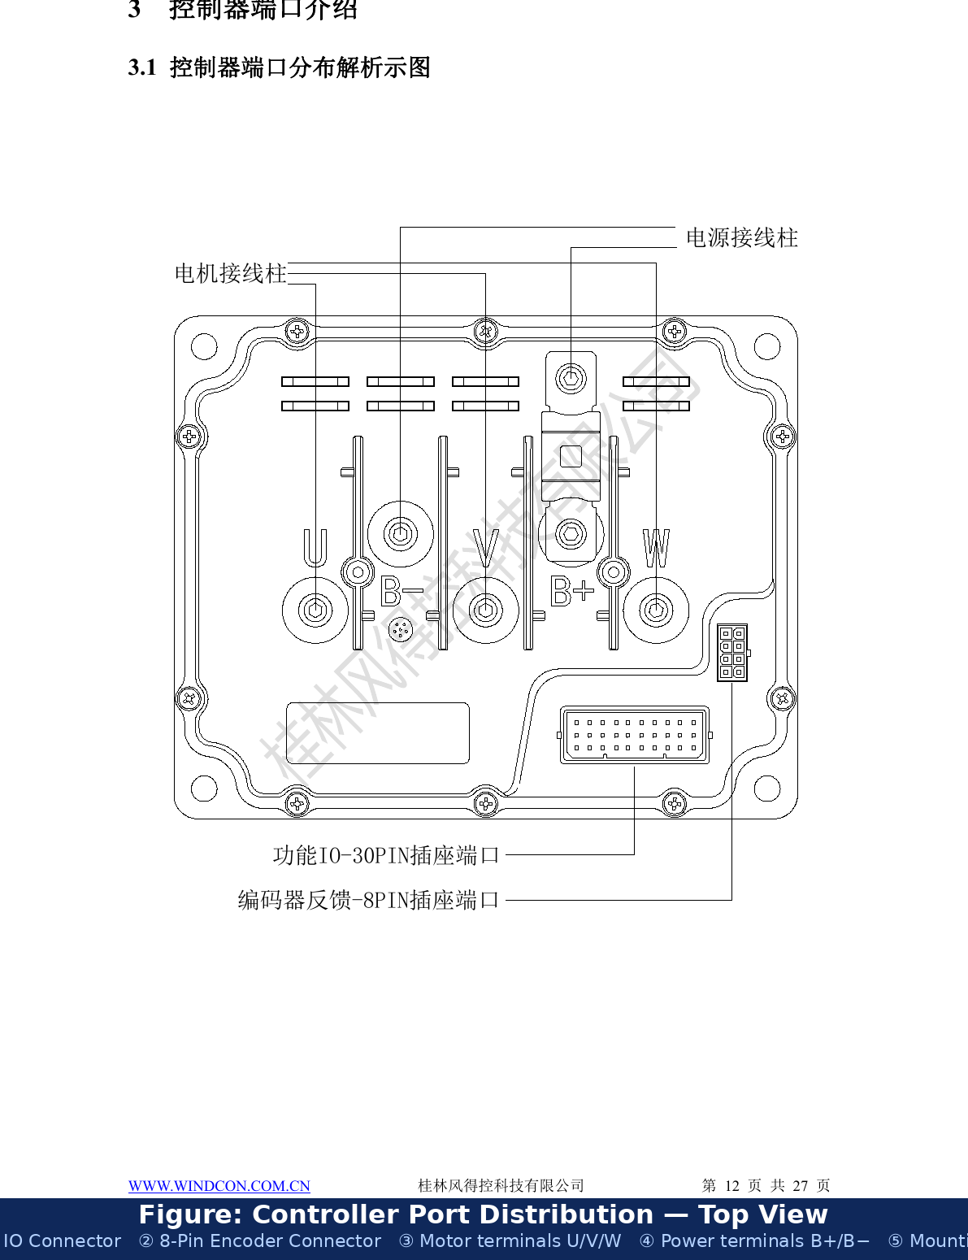
Figure 2 — Controller port distribution — original technical drawing with English labels added

Area | Connector / Terminals | Contents
Power & Motor | 5× stud terminals (B+, B−, U, V, W) | Battery +/− and motor phases (25–36 mm² cable)
Functional IO | 30-pin connector (Connector A) | Signals, CAN, RS485, throttle, brakes, key switch, speed, READY
Encoder Feedback | 8-pin connector (Connector B) | Resolver SIN/COS/REF (±) and motor temperature sensor
Mechanical Mounting | 4× mounting holes | Diameter Ø8.5 mm, M8 bolts, 185×145 mm bolt pattern

3.2 30-Pin IO Connector (Connector A)
Connector type: Electric vehicle controller 30P harness connector plug. Wire colors listed are for reference — actual harness colors may vary.

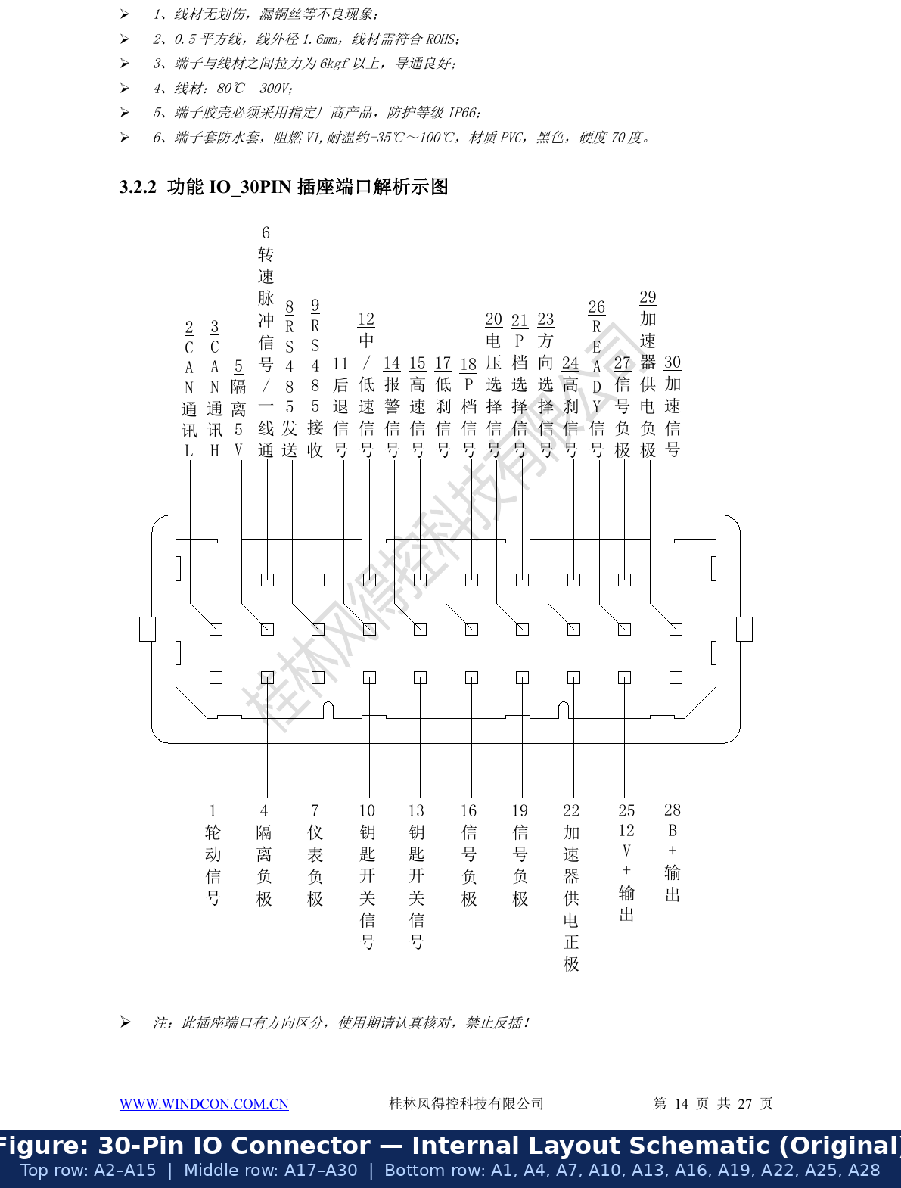
Figure 3 — 30-Pin IO connector — original layout schematic with English labels

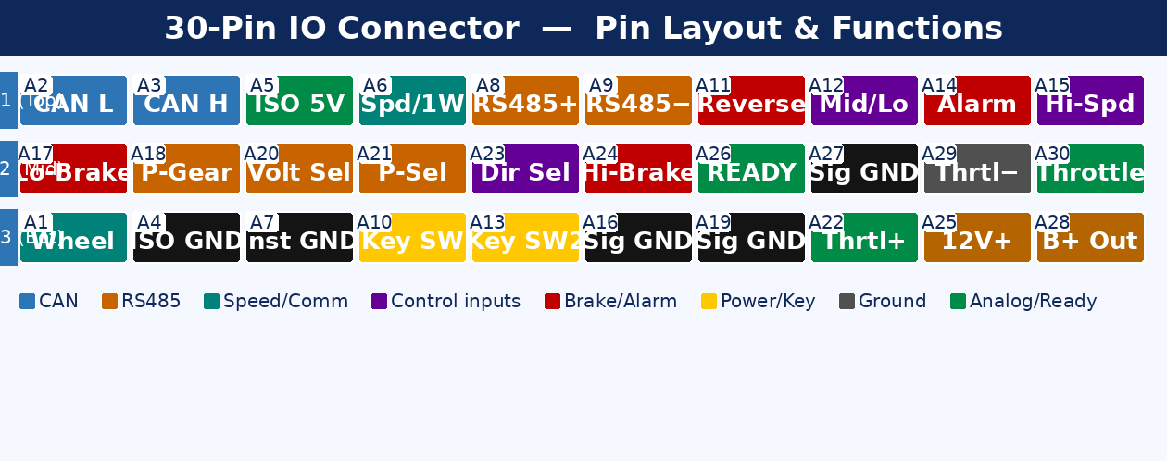
Figure 4 — 30-Pin IO connector — color-coded pin map by signal type

PIN | Wire Color | Signal Name | Description
A1 | Brn/Wht | Wheel Motion | Pulse output when motor rotates — connect to alarm/buzzer
A2 | Red/Wht | CAN Comm. L | CAN bus Low (protocol customizable per application)
A3 | Red | CAN Comm. H | CAN bus High (protocol customizable per application)
A4 | LGrn/Wht | Isolated GND | CAN/RS485 isolation ground — connect to chassis in noisy environments
A5 | Pnk/Wht | Isolated 5V | Isolated 5V output (max 100 mA) — reserved for Bluetooth module
A6 | Grn/Wht | Speed Pulse / 1-Wire | 8 pulses/rev (5V) for speedometer, OR single-wire instrument comm.
A7 | Black | Instrument GND | Ground wire for pulse-type speedometers
A8 | Blu/Wht | RS485 T+ | RS485 transmit positive — commissioning or command control
A9 | Pur/Wht | RS485 T− | RS485 transmit negative — commissioning or command control
A10 | Purple | Key Switch | Control circuit power supply (battery B+ input via key switch)
A11 | Brown | Reverse | Active LOW → reverse motor direction
A12 | Orange | Mid/Low Speed | Active LOW → switch to mid/low speed mode
A13 | Purple | Key Switch (Alarm) | Alarm unit sends key-on signal to start controller
A14 | Lt Blue | Alarm / Lock | Active LOW → alarm active, motor locked (anti-theft)
A15 | Blue | High Speed | Active LOW → high speed mode with flux weakening
A16 | Black | Signal GND | Common GND for all active-low signal inputs
A17 | Gray | Low Brake | Active LOW → brake engage (typically brake lever switch)
A18 | Yellow | P-Gear | Active LOW → enter/exit parking gear mode
A19 | Black | Signal GND | Common GND for active-low signals
A20 | Org/Wht | Voltage Selection | Active LOW → switch battery voltage profile (48/60/72V)
A21 | Yel/Blk | P-Gear Select | Active LOW → enable or disable P-gear feature
A22 | Pink | Throttle Supply + | 5V output to power throttle sensor (max 200 mA)
A23 | Black | Direction Select | Active LOW → swap motor phase lines to reverse direction
A24 | Gry/Wht | High Brake | Active HIGH (12V) → brake engage — use A25 as 12V source
A25 | Lt Green | 12V+ Output | 12V output for active-high switch signals only (max 200 mA)
A26 | White | READY Signal | 5V output to light READY lamp on instrument cluster
A27 | Blk/Wht | Signal GND | Common GND for active-low signals
A28 | Yel/Wht | B+ Output | Battery voltage output for key switch signals only (max 1 A)
A29 | Black | Throttle GND | Ground for throttle power supply circuit
A30 | Green | Throttle Signal | Throttle analog input 0–5V (from throttle/accelerator sensor)

⚠ CAUTION — 30-Pin Connector
- Connector has a specific insertion direction — NEVER insert reversed, this WILL cause damage!
- Wire harness spec: 0.5 mm² ROHS, pull force ≥6 kgf, IP66 housing, rated 80°C 300V.

3.3 8-Pin Encoder Feedback Connector (Connector B)
Carries all resolver signals plus motor temperature. Always use shielded cable. Ground shield at controller end only.

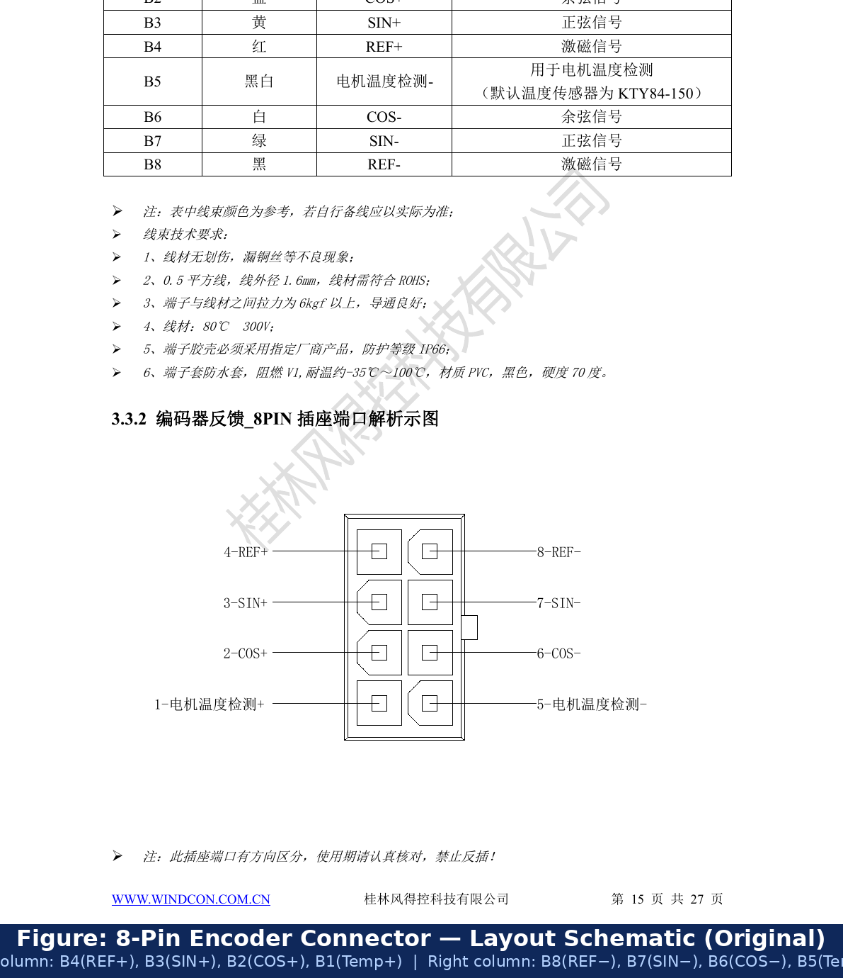
Figure 5 — 8-Pin encoder connector — original layout schematic with English labels

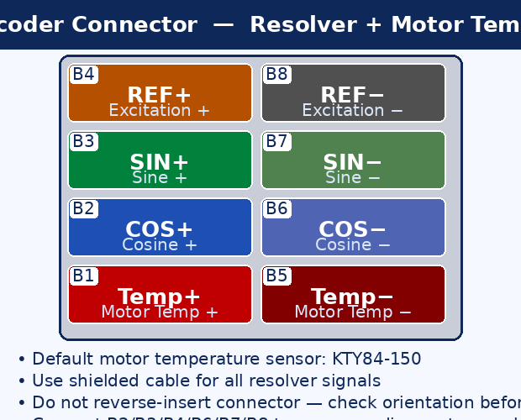
Figure 6 — 8-Pin encoder connector — color-coded SIN/COS/REF and motor temperature diagram

PIN | Wire Color | Signal Name | Description
B1 | Red/Wht | Motor Temp (+) | Motor temperature sensor positive — default KTY84-150
B2 | Blue | COS+ | Resolver cosine signal positive
B3 | Yellow | SIN+ | Resolver sine signal positive
B4 | Red | REF+ | Resolver excitation/reference signal positive (~10 kHz AC)
B5 | Blk/Wht | Motor Temp (−) | Motor temperature sensor negative — default KTY84-150
B6 | White | COS− | Resolver cosine signal negative
B7 | Green | SIN− | Resolver sine signal negative
B8 | Black | REF− | Resolver excitation/reference signal negative

⚠ CAUTION — 8-Pin Encoder Connector
- Connector has a specific insertion direction — check carefully; reverse insertion is PROHIBITED!
- Non-KTY84-150 temperature sensors require Windcon engineering adaptation before use.
- Use shielded cable for all resolver signals. Ground shield at controller end only.

3.4 Power & Motor Terminal Studs

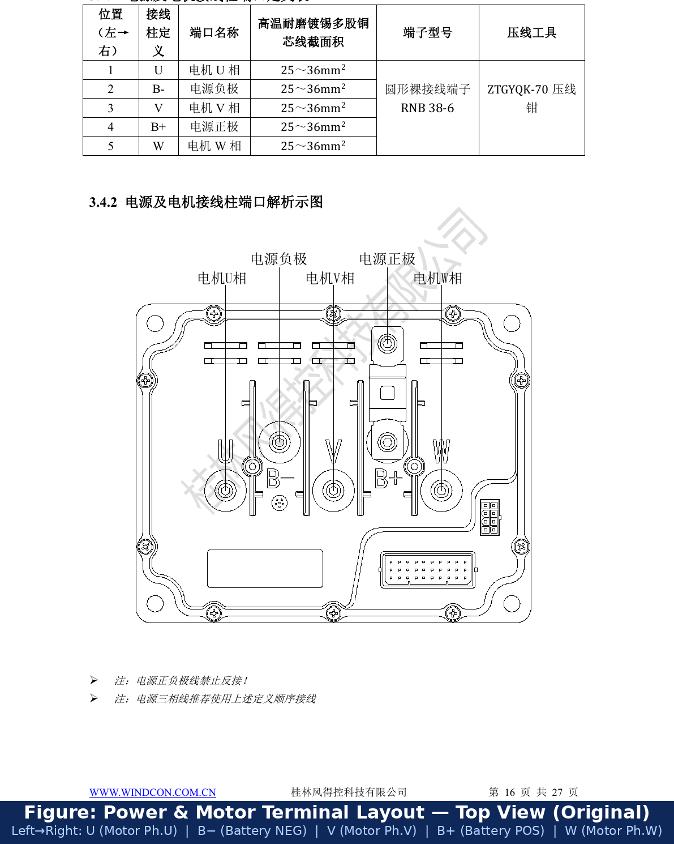
Figure 7 — Power and motor terminal layout — original technical drawing with English labels

Position | Label | Function | Cable Size | Terminal | Crimp Tool
1 (leftmost) | U | Motor Phase U | 25–36 mm² | RNB 38-6 | ZTGYQK-70
2 | B− | Battery Negative | 25–36 mm² | RNB 38-6 | ZTGYQK-70
3 | V | Motor Phase V | 25–36 mm² | RNB 38-6 | ZTGYQK-70
4 | B+ | Battery Positive | 25–36 mm² | RNB 38-6 | ZTGYQK-70
5 (rightmost) | W | Motor Phase W | 25–36 mm² | RNB 38-6 | ZTGYQK-70

⚠ WARNING — Power Terminals
- NEVER reverse Battery B+ and B− connections!
- Recommended wiring order left→right: U → B− → V → B+ → W
- Cables must be 25–36 mm² tinned multi-strand copper. Crimp only with ZTGYQK-70 tool.

4 Controller Resource Configuration

4.1 Signal Inputs (11 total)
PIN | Signal Name | Trigger Type | Input Range | Max Voltage
A11 | Reverse | Active Low (0V typ.) | 0–0.2 V | 24V
A12 | Mid/Low speed | Active Low (0V typ.) | 0–0.2 V | 24V
A14 | Alarm / Motor lock | Active Low (0V typ.) | 0–0.2 V | 24V
A15 | High speed | Active Low (0V typ.) | 0–0.2 V | 24V
A17 | Low brake | Active Low (0V typ.) | 0–0.2 V | 24V
A18 | P-gear | Active Low (0V typ.) | 0–0.2 V | 24V
A20 | Voltage selection | Active Low (0V typ.) | 0–0.2 V | 24V
A21 | P-gear select | Active Low (0V typ.) | 0–0.2 V | 24V
A23 | Direction select | Active Low (0V typ.) | 0–0.2 V | 24V
A24 | High brake | Active High (12V typ.) | 10–18 V | 24V
A30 | Throttle (analog) | 0–5V nominal | 0–10 V | 12V

⚠ CAUTION — Signal Inputs
- All signals must operate within their typical voltage range. Exceeding limits may damage the controller.
- Inputs are positive-voltage triggered. Reference ground is B−. Never inject negative voltage.

4.2 Signal Output
PIN | Signal | Output Voltage | Max Current
A26 | READY | 5V ±2% | 50 mA

4.3 Voltage Outputs (4 total)
PIN | Signal | Voltage | Max Current | Permitted Use
A5 | Isolated 5V | 5V ±2% | 100 mA | Bluetooth module only
A22 | Throttle supply + | 5V ±2% | 200 mA | Throttle or hall sensor power
A25 | 12V+ output | 12V ±2% | 200 mA | Active-high (12V) switch signals only
A28 | B+ output | Battery voltage | 1 A | Key switch signal only

⚠ CAUTION — Voltage Outputs
- These outputs may ONLY power: throttle, Bluetooth, linear brake, key switch, active-high IO.
- Do NOT use to power vehicle lights, instruments, or other loads — overcurrent damages controller.
- Never inject external voltage into any output pin.

4.4 Communication Interfaces
Interface | Pins | Type | Key Notes
CAN Bus | A2 (CAN L), A3 (CAN H) | Isolated CAN | Built-in 120Ω. Add external 120Ω at both bus ends. Protocol customized by Windcon.
CAN Isolation GND | A4 (ISO_GND) | Isolation GND | Connect to chassis ground in high-interference environments.
RS485 | A8 (T+), A9 (T−) | Isolated RS485 | Built-in 120Ω. For commissioning and command-mode control.
Pulse Speedometer | A6, A7 (GND) | 5V pulse output | 8 pulses/revolution (5V). A7 = instrument GND. Default factory mode for A6.
Single-Wire Comm. | A6 only | Single-wire | Firmware-selected mode. Protocol requires Windcon customization. A7 not used.
CAN Instrument | A2, A3 | Isolated CAN | Shared CAN bus with BMS/VCU. Protocol customized separately.

4.5 Encoder and Temperature Feedback
Pins | Signal | Type | Notes
B2 (COS+), B6 (COS−) | Cosine signal | Resolver differential | Connect to motor resolver coil wires
B3 (SIN+), B7 (SIN−) | Sine signal | Resolver differential | Connect to motor resolver coil wires
B4 (REF+), B8 (REF−) | Excitation / REF | ~10 kHz AC | Supplied by controller DSP to resolver primary winding
B1, B5 | Motor temperature | KTY84-150 (default) | Other sensor types require Windcon engineering adaptation

4.6 Original Wiring Diagrams
The following two diagrams are the original factory wiring schematics translated to English. They show how all 30 IO pins and all 8 encoder pins connect in a complete vehicle installation.

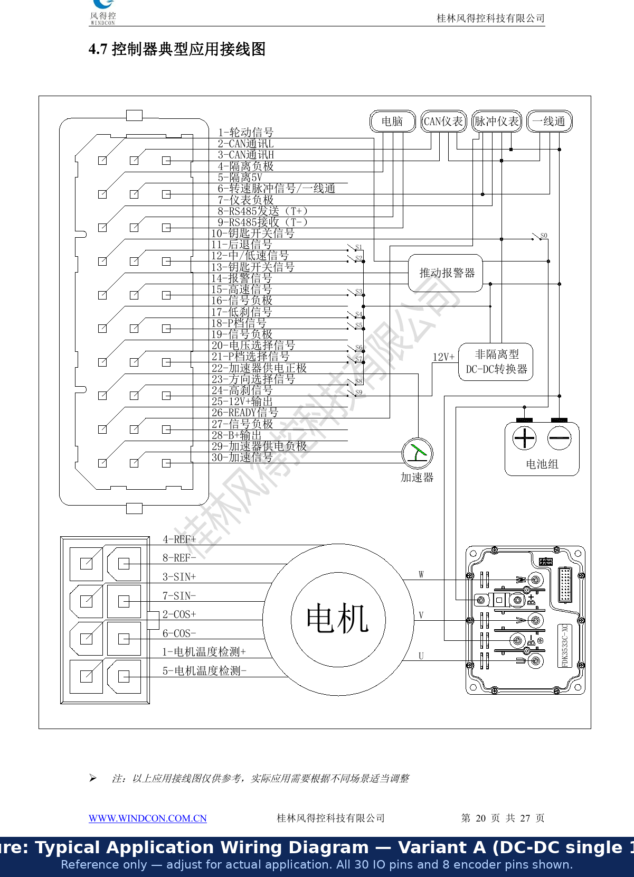
Figure 9 — Typical application wiring diagram — Variant A (single DC-DC, 12V only)

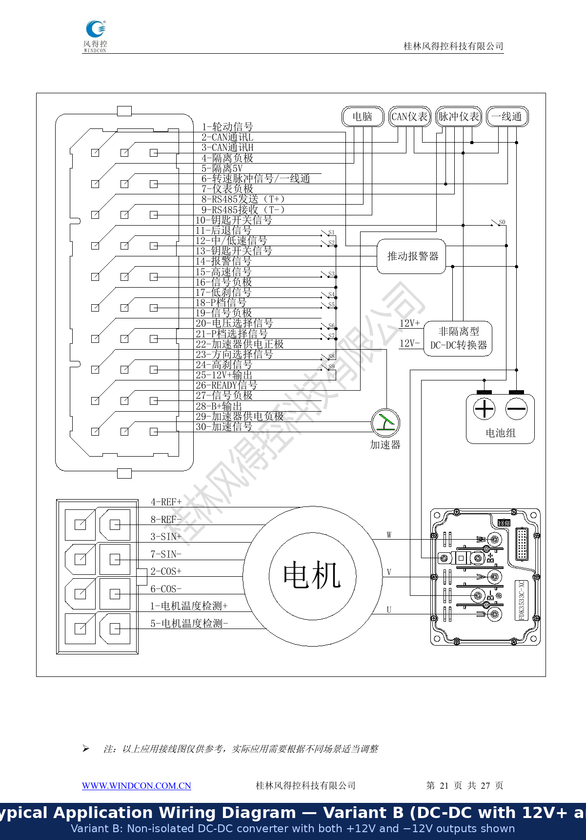
Figure 10 — Typical application wiring diagram — Variant B (DC-DC with 12V+ and 12V−)

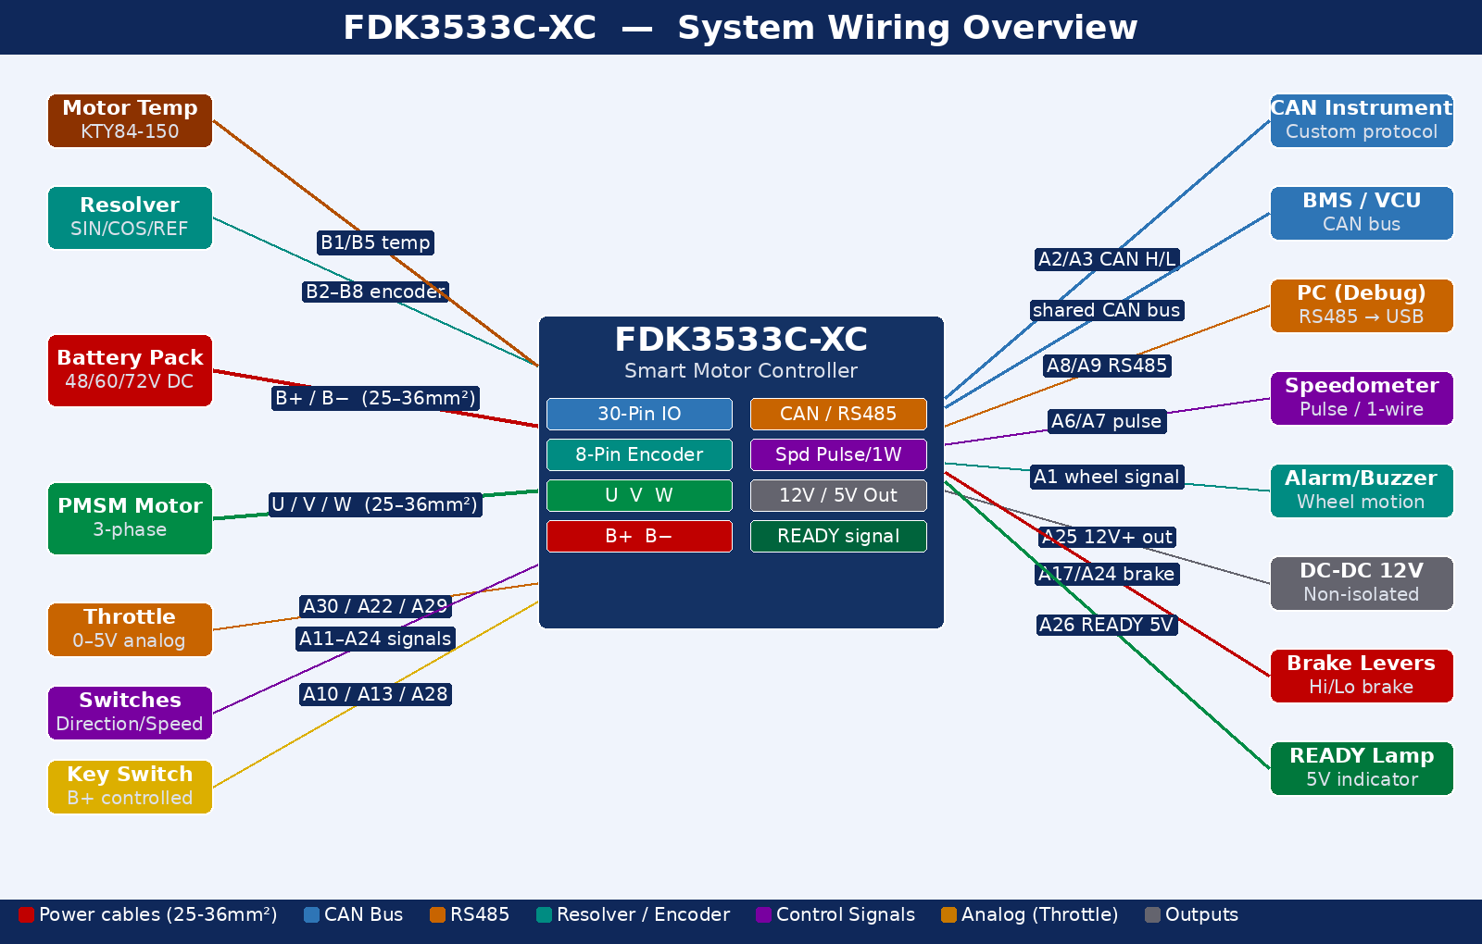
Figure 11 — System wiring overview — all external connections with color-coded signal paths

5 Installation

5.1 Environmental Requirements
- Do NOT install in corrosive gas/liquid, flammable/explosive, water/steam/oil/dust, or high-heat environments
- Do NOT install where severe electromagnetic interference or severe grid fluctuations are present
- For vibration environments: contact Windcon technical support before installation

5.2 Mechanical Dimensions and Mounting

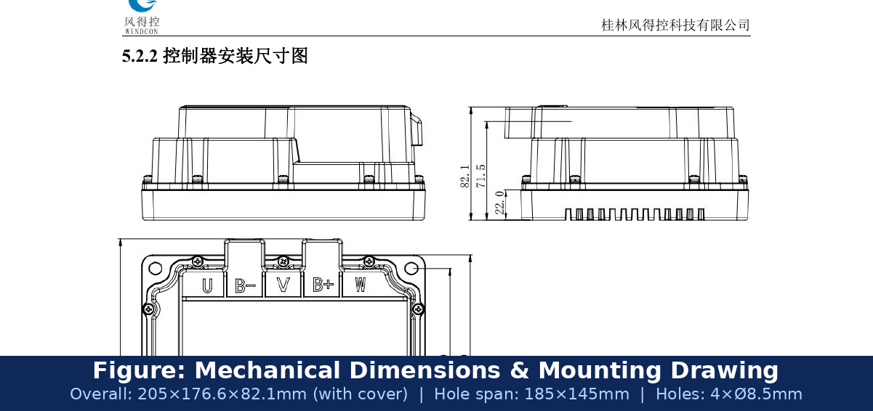
Figure 8 — Mechanical installation dimensions — original factory drawing

Dimension | Value
Overall length | 205.0 mm
Width (without rain cover) | 165.0 mm
Width (with rain cover) | 176.6 mm
Height (without rain cover) | 71.5 mm
Height (with rain cover) | 82.1 mm
Mounting hole span (length) | 185.0 mm (centre-to-centre)
Mounting hole span (width) | 145.0 mm (centre-to-centre)
Mounting hole diameter | 4× Ø8.5 mm — M8 bolts recommended
Base-to-datum offset | 22.0 mm

5.3 Electrical Installation Safety
- All external wiring must be performed by trained, authorized engineers only.
- Wiring must follow the wiring diagrams and this manual exactly.
- Check controller voltage rating before powering on — mismatch causes damage or fire.
- During energized servo state, no personnel may enter the mechanical movement zone.
- Cut ALL system power and wait at least 10 minutes before opening the controller housing.
- The controller has been factory dielectric-tested — do NOT repeat dielectric strength tests.
- NEVER connect the power supply to motor output terminals U, V, or W.
- Both controller and motor must be reliably grounded.
- Connect controller to supply via circuit breaker or fuse for input overcurrent protection.

5.4 Post-Installation Inspection Checklist
Inspection Item | Pass Criteria
Controller physical condition | No damage; securely mounted; heatsink fins unobstructed
Cable condition | No damage/breaks; power cables separate from signal and encoder cables
Connector mating | All connectors fully mated; no mechanical tension; sufficient cable slack
Power polarity | B+ and B− correct; power NOT connected to signal or encoder ports
Motor phase sequence | U, V, W correct sequence; no stripped insulation on power cables
Ground connections | Power and ground cables correctly and firmly connected; equipment grounded
Terminal voltages | All terminals within typical supply range; no over-voltage
Encoder wiring | Resolver lines correctly matched; shielded cable used; shield grounded at one end

6 Commissioning
Commissioning software: 'Windcon Debug Assistant'. Refer to its user manual for detailed usage. If a version mismatch error appears at startup, a startup configuration file is missing — contact Windcon to obtain it.

6.1 Commissioning Sequence
Step | Action | Critical Notes
1 | Mount controller in a ventilated location | Heatsink must have clearance for airflow. Do not obstruct fins.
2 | Wire B+, B−, U, V, W power terminals | Verify polarity. Follow recommended phase order. Crimp properly.
3 | Wire resolver encoder B2–B8 and motor temp B1/B5 | Use shielded cable. Check 8-pin connector orientation before mating.
4 | Wire all 30-pin IO signals | Key switch, throttle (A22/A29/A30), brakes, direction, speed selector.
5 | Set motor to NO LOAD — no mechanical load attached | REQUIRED for all initial commissioning and electrical angle zeroing.
6 | Connect PC to RS485 via USB adapter | Open Windcon Debug Assistant software on PC.
7 | Power ON the controller | Listen for alarm beep codes (see Section 8). Silence = normal startup.
8 | Verify PC communication with controller | Read all parameters; confirm voltage setting matches battery pack.
9 | Run current loop test | Feedback RPM MUST be POSITIVE. If negative → change Swap Phase Lines (0↔1).
10 | Perform electrical angle zeroing | Motor must be unloaded. Repeat 3+ times. Offset error must be <±50.
11 | Test throttle response | Slow ramp-up; verify smooth speed control, no oscillation or hunting.
12 | Test brakes, direction, and speed selector | All safety and control inputs must function before load testing.
13 | Gradually test under increasing load | Monitor motor and controller temperatures during extended runs.

6.2 Key Parameters to Verify
Parameter | Function | What to Check / Set
Motor rated current | Sets current limit protecting motor | Must not exceed controller rated value; confirm with motor nameplate
Motor pole pairs | Used in RPM formula: RPM = freq×60÷pole pairs | Incorrect value causes wrong speed display and control instability
Swap motor phase lines (0/1) | Reverses motor rotation direction | Set so feedback speed is POSITIVE in current loop test
Electrical angle zero offset | Sets rotor position reference for FOC | Must be within ±50 after repeated zeroing for stable control
Battery voltage level | Configures protection thresholds for 48/60/72V | Must match actual battery pack nominal voltage
Maximum output current | Limits peak current during acceleration | Verify before first run — too high damages motor windings

7 Typical Problems and Fault Analysis

7.1 Vibrates Slowly or Does Not Move After Throttle
Item | Detail
Symptom | Wiring correct; after gentle throttle, vehicle vibrates slowly or does not move at all
Meaning | Controller IS producing output — two possible causes:
Cause A | Motor encoder OK but phase sequence wrong. Change parameter Swap Motor Phase Lines (toggle 0↔1) until current loop feedback speed becomes POSITIVE.
Cause B | Motor encoder abnormal: power supply issue, wire break, poor contact, incorrect pin sequence, or encoder damage.
Note | Changing Swap Motor Phase Lines is only effective when the encoder is functioning correctly.

7.2 Vehicle Does Not Move or Overspeeds (Runaway) After Throttle
Check | Action Required
Check 1 — Phase direction | Current loop test: feedback RPM MUST be POSITIVE and satisfy: RPM = (output frequency × 60) ÷ pole pairs. If negative → swap phase lines.
Check 2 — Encoder signal | Motor rotates but no speed feedback → inspect B2–B8 wiring; replace encoder if wiring confirmed correct.
Check 3 — Angle zeroing | Resolver electrical angle offset wrong. With Check 1 satisfied, re-zero (repeat multiple times). Offset must be within ±50.
Check 4 — Hardware | If all above checks pass and fault persists → hardware damage; return to factory.

7.3 No Response After Key-On and Throttle
Required Condition | How to Verify
Direction signal present | Check that forward or reverse input is active (A11 for reverse, default is forward)
No brake signal active | Verify no brake lever engaged; measure A17 (low brake) and A24 (high brake)
Throttle output present | Measure A30: must rise from ~0.8V (idle) to ~4.2V (full throttle)
Supply voltage above threshold | Measure battery voltage; compare with configured under-voltage limit in software

8 Fault Alarms and Remedies
The controller signals faults through the buzzer using Long (L) and Short (S) beep patterns. Each pattern repeats continuously until the fault is resolved.
Timing: Long beep ~0.8 s | Short beep ~0.2 s | Gap ~0.2 s

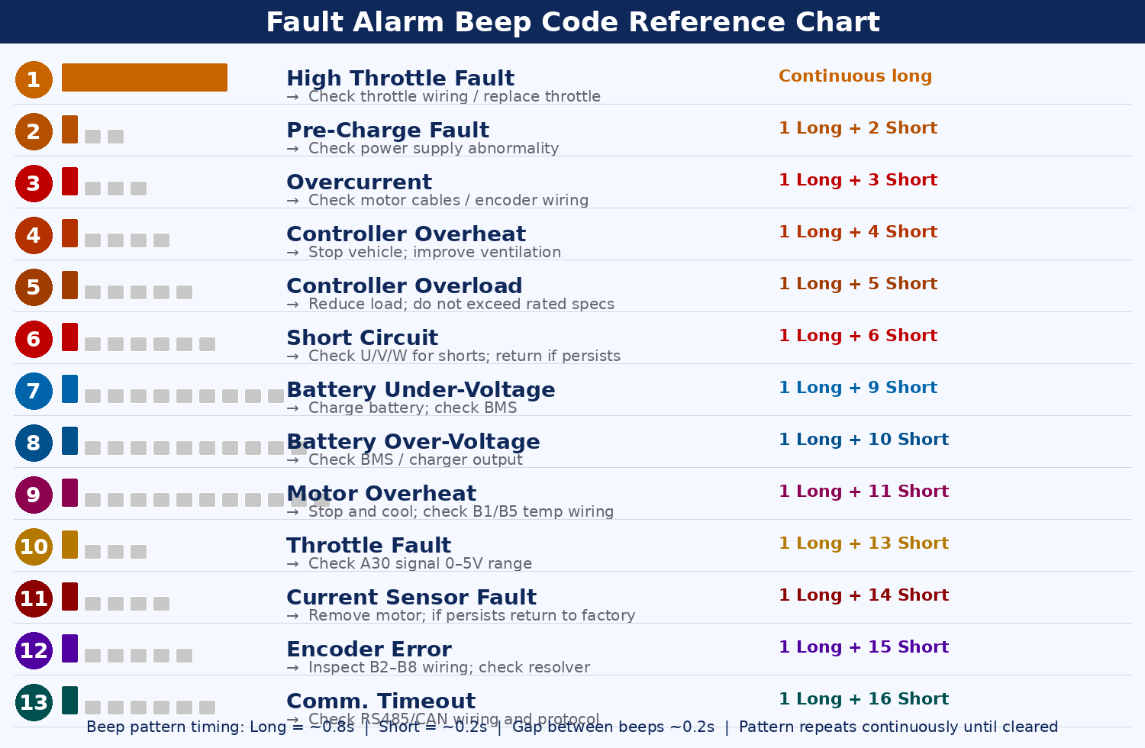
Figure 15 — Fault alarm beep code reference chart — all 13 fault codes with visual beep patterns

No. | Pattern | Fault Name | Cause and Remedy
1 | Continuous long | High Throttle Fault | Throttle held at power-on. Release throttle and restart. Persistent → check A30/A22/A29 wiring.
2 | 1L + 2S | Pre-Charge Fault | Pre-charge failed. Restart. Persistent → check power supply, main fuse, BMS output voltage.
3 | 1L + 3S | Overcurrent | Motor circuit short or encoder abnormality. Remove motor and restart. Persistent → return to factory.
4 | 1L + 4S | Controller Overheat | Controller too hot. Stop and cool. Improve mounting ventilation.
5 | 1L + 5S | Controller Overload | Output current exceeded rated for too long. Reduce load.
6 | 1L + 6S | Short Circuit | Motor main circuit short or current loss. Remove motor and restart. Persistent → return to factory.
7 | 1L + 9S | Battery Under-Voltage | Supply below threshold. Charge battery; check BMS; check B+/B− wiring.
8 | 1L + 10S | Battery Over-Voltage | Supply above threshold. Check BMS and charger output.
9 | 1L + 11S | Motor Overheat | Motor too hot. Stop and cool. Fault persists after cooling → check B1/B5 wiring.
10 | 1L + 13S | Throttle Fault | Throttle signal abnormal. Check A30 is within 0–5V range throughout travel.
11 | 1L + 14S | Current Sensor Fault | Output current detection abnormal. Remove motor and restart. Persistent → return to factory.
12 | 1L + 15S | Encoder Error | Resolver mismatch or signal fault. Inspect all B2–B8 wiring and resolver.
13 | 1L + 16S | Comm. Timeout | Communication disconnected in command-control mode. Check RS485/CAN wiring.

8.1 General Fault Resolution Steps
- Note the exact alarm beep pattern and identify the fault from the table above.
- Power off completely and wait at least 15 minutes (capacitor discharge).
- Address the specific cause described for that fault code.
- Power on and verify the fault is cleared (no alarm beep).
- If fault persists after all listed checks, contact Windcon technical support or return to factory.

⚠ DANGER — Never diagnose faults while energized!
- Always cut all power and wait at least 15 minutes before inspecting wiring or components.
- When returning for repair, document the exact beep pattern and operating conditions observed.

Appendix A — List of Figures

Figure 1 FDK3533C-XC Annotated Controller Photo — All Major Components Labelled | (see page)
Figure 2 Controller Port Distribution — Original Technical Drawing (English Labels) | (see page)
Figure 3 30-Pin IO Connector — Original Layout Schematic (English Labels) | (see page)
Figure 4 30-Pin IO Connector — Color-Coded Pin Map by Signal Type | (see page)
Figure 5 8-Pin Encoder Connector — Original Layout Schematic (English Labels) | (see page)
Figure 6 8-Pin Encoder Connector — Color-Coded SIN/COS/REF Diagram | (see page)
Figure 7 Power & Motor Terminal Layout — Original Technical Drawing (English Labels) | (see page)
Figure 8 Mechanical Installation Dimensions — Original Factory Drawing | (see page)
Figure 9 Typical Application Wiring Diagram — Variant A (Single 12V DC-DC) | (see page)
Figure 10 Typical Application Wiring Diagram — Variant B (Dual 12V DC-DC) | (see page)
Figure 11 System Wiring Overview — All External Connections with Color-Coded Signal Paths | (see page)
Figure 12 Resolver (Rotary Transformer) — Operating Principle and Signal Waveforms | (see page)
Figure 13 FOC / SVPWM Vector Control Loop — Complete Block Diagram | (see page)
Figure 14 Signal Logic Guide — Active High vs. Active Low vs. Analog Throttle | (see page)
Figure 15 Fault Alarm Beep Code Reference Chart — All 13 Fault Codes | (see page)
Figure 16 Integration Guide — Connecting Nine External Sub-Systems | (see page)
Figure 17 Commissioning Flowchart — Complete Initial Setup Procedure | (see page)

Appendix B — List of Abbreviations

Abbreviation | Full Term | Meaning / Context in This Manual
ADC | Analog-to-Digital Converter | Converts throttle voltage on A30 (0–5V) to a digital speed command inside the controller DSP
BMS | Battery Management System | External device managing battery charge, discharge, and cell protection; connects via CAN bus
CAN | Controller Area Network | ISO 11898 serial bus; connected on A2 (CAN L) and A3 (CAN H); used for instruments, BMS, VCU
COS | Cosine | One of two differential resolver output signals; carries rotor angle as amplitude-modulated cosine wave
DSP | Digital Signal Processor | High-speed processor inside controller performing FOC, PWM, and resolver calculations in real time
EMC | Electromagnetic Compatibility | Use shielded cables and proper grounding to ensure compliance and prevent interference
ESD | Electrostatic Discharge | Static electricity that can damage electronics; wear anti-static wristband when wiring
FOC | Field-Oriented Control | Vector control algorithm that independently controls torque and flux currents for smooth, efficient operation
GND | Ground | Electrical reference potential (0V). All signal inputs are referenced to B− (battery negative)
Id | D-axis Current | Direct-axis (flux-producing) current in the FOC rotating reference frame; controls field weakening
Iq | Q-axis Current | Quadrature-axis (torque-producing) current in the FOC rotating reference frame; controls torque output
IO | Input/Output | General term for signal pins on the 30-pin connector (Connector A)
IP65 | Ingress Protection 65 | Dust-tight and protected against low-pressure water jets; the controller housing protection rating
KTY84-150 | Temperature Sensor | Silicon PTC thermistor, -50°C to +150°C range; default motor temperature sensor (B1/B5)
NDA | Non-Disclosure Agreement | This document is for internal use under NDA only — do not distribute externally
PI | Proportional-Integral | Feedback control algorithm used in FOC speed loop and current loops to minimize steady-state error
PMSM | Permanent Magnet Synchronous Motor | Three-phase AC motor with permanent magnets on rotor; the motor type this controller drives
PWM | Pulse Width Modulation | High-frequency switching used to control average voltage/current to motor phases
REF | Reference / Excitation | ~10 kHz AC signal generated by DSP and supplied to resolver primary winding via B4/B8
ROHS | Restriction of Hazardous Substances | EU directive; all wire harness materials must comply
RPM | Revolutions Per Minute | Motor speed. Formula: RPM = output frequency × 60 ÷ motor pole pairs
RS485 | Recommended Standard 485 | Differential serial standard; used for commissioning and command control on A8/A9
SIN | Sine | One of two differential resolver output signals; carries rotor angle as amplitude-modulated sine wave
SVPWM | Space Vector PWM | Advanced modulation in FOC; maximizes voltage utilization and reduces harmonic distortion
VCU | Vehicle Control Unit | Higher-level vehicle computer sending speed/torque commands to this controller via CAN bus

Appendix C — Technical Explainer Diagrams
This appendix provides six original technical diagrams explaining how the FDK3533C-XC operates internally and how to correctly integrate it with external systems.

C.1 Resolver (Rotary Transformer) — Operating Principle
The FDK3533C-XC uses a resolver instead of hall sensors or optical encoders. A resolver is a contactless electromagnetic angle sensor that outputs differential sine and cosine voltages whose amplitudes vary with rotor position. The controller DSP supplies a ~10 kHz excitation signal to the resolver primary winding and reads back the modulated SIN/COS outputs to calculate absolute rotor angle (θ) and speed. This gives ~0.1° resolution with no breakable parts, no magnets to demagnetize, and operation from −55°C to +155°C.

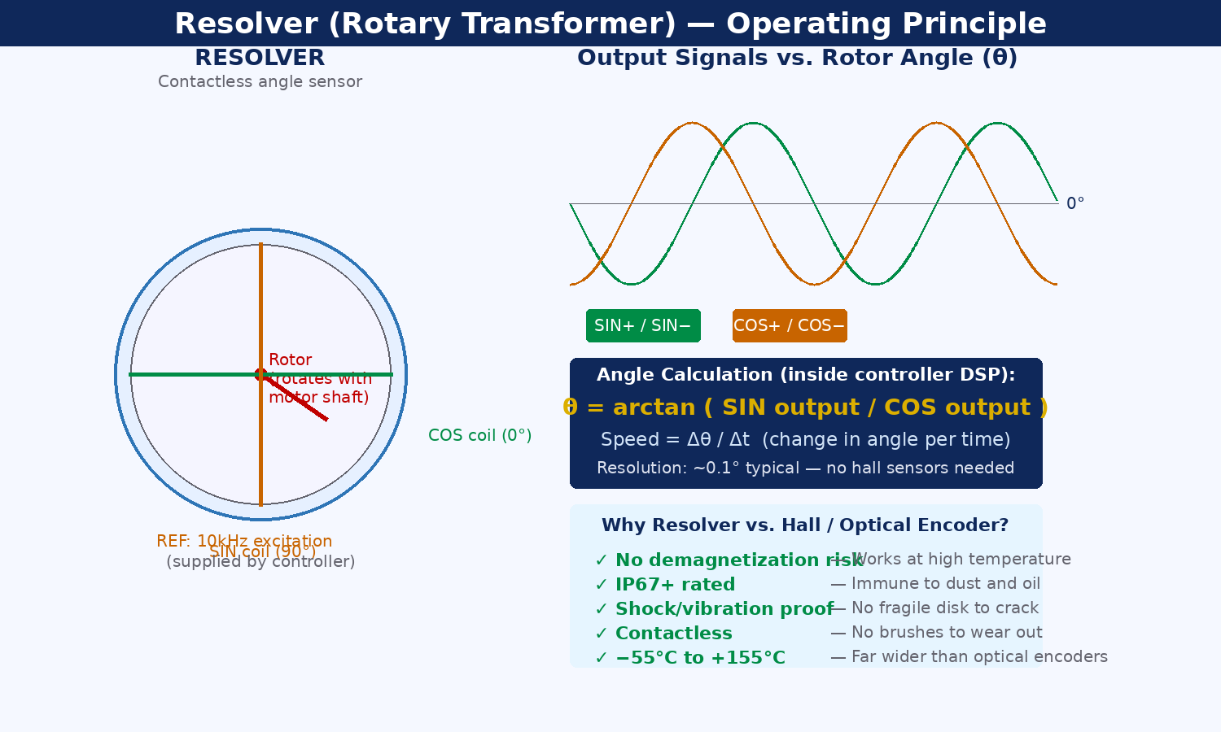
Figure 12 — Resolver operating principle — physical diagram, signal waveforms, angle formula, and advantages vs. alternatives

C.2 FOC / SVPWM Vector Control Loop
The controller implements full closed-loop FOC using Space Vector PWM. Three-phase currents are transformed into a rotating d-q reference frame; torque current (Iq) and flux current (Id) are controlled independently by PI regulators; results are inverse-transformed back to three-phase voltages and modulated via SVPWM to drive the IGBT/MOSFET inverter. This delivers smooth, efficient, precise torque at all speeds — superior to trapezoidal or ON/OFF commutation.

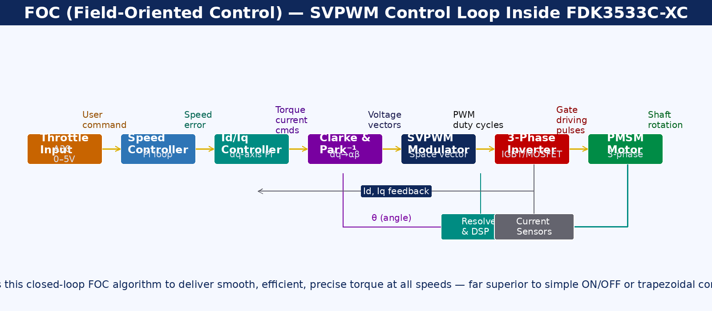
Figure 13 — FOC / SVPWM vector control loop — complete block diagram from throttle to motor shaft

C.3 Signal Logic Guide — Active High vs. Active Low vs. Analog Throttle
Most control inputs use active-low logic (triggered by connecting to GND). The high-brake input A24 uses active-high (12V). The throttle A30 is a 0–5V analog signal. Understanding these differences is critical for correct wiring and fault diagnosis.

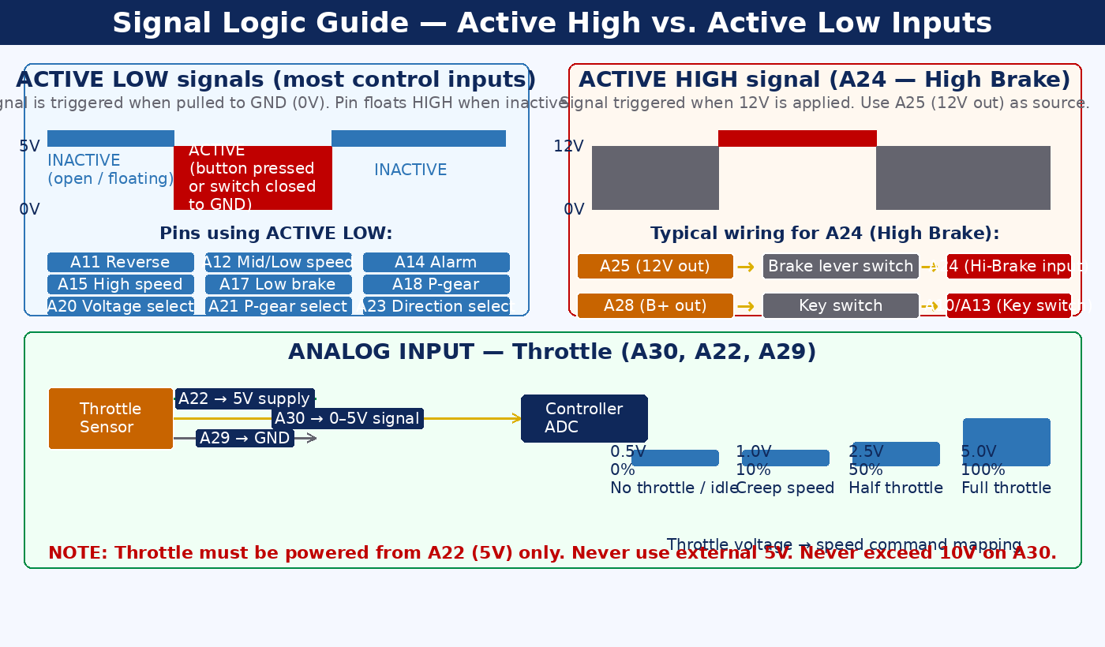
Figure 14 — Signal logic guide — timing diagrams, wiring circuits, and throttle voltage mapping

C.4 Fault Alarm Beep Code Reference Chart
All 13 fault codes are illustrated with visual beep-pattern bars, fault names, and remedies. This chart is a field-ready quick-reference. See Section 8 for full descriptions. Tape or laminate a copy near the installation for maintenance use.

C.5 Integration Guide — Connecting External Systems
This nine-panel diagram shows the exact pins, wiring rules, and critical notes for connecting: CAN bus, RS485 commissioning, instrument types (pulse, single-wire, CAN), throttle, brakes (low and high), 3-speed selector, motor direction, battery voltage selection, and anti-theft motor lock.

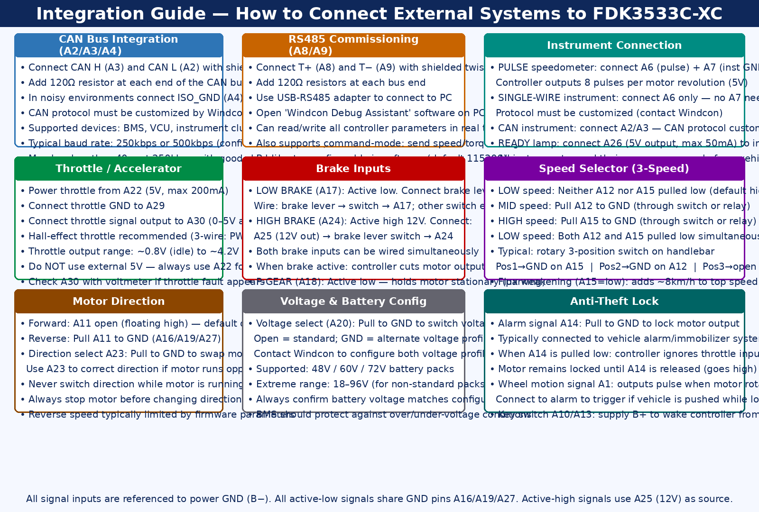
Figure 16 — Integration guide — nine external sub-systems with pin numbers, wiring rules, and critical notes

C.6 Commissioning Flowchart
This step-by-step flowchart covers the full initial commissioning procedure. Critical decision points are highlighted: current loop test (Step 9, feedback MUST be POSITIVE) and electrical angle zeroing (Step 10, error must be within ±50). Never skip unloaded testing or the zeroing procedure.

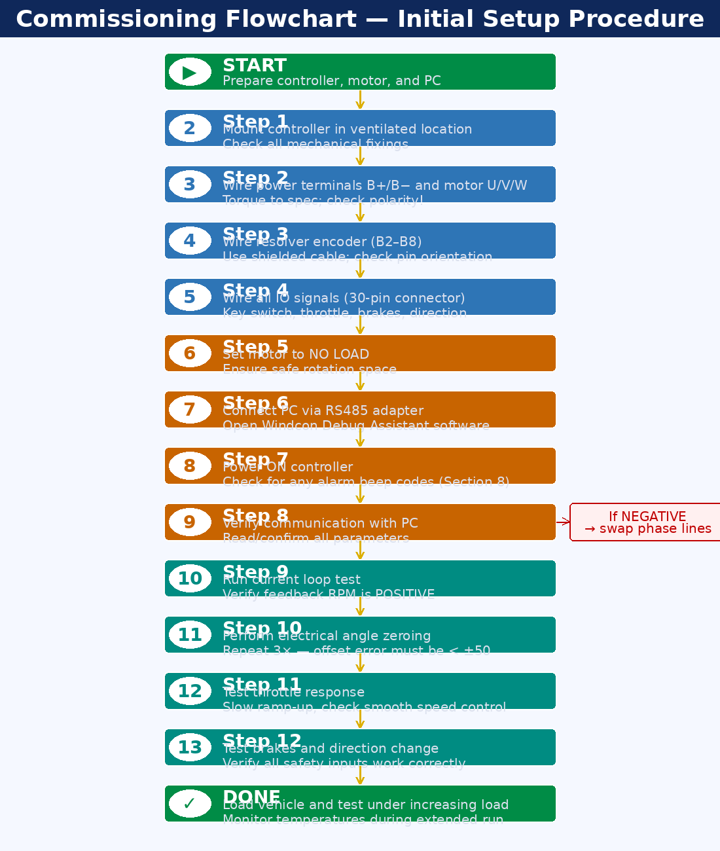
Figure 17 — Commissioning flowchart — complete initial setup procedure with decision points

Guilin Windcon Technology Co., Ltd.
www.windcon.com.cn | FDK3533C-XC User Manual V1.0 EN | For internal / NDA use only

